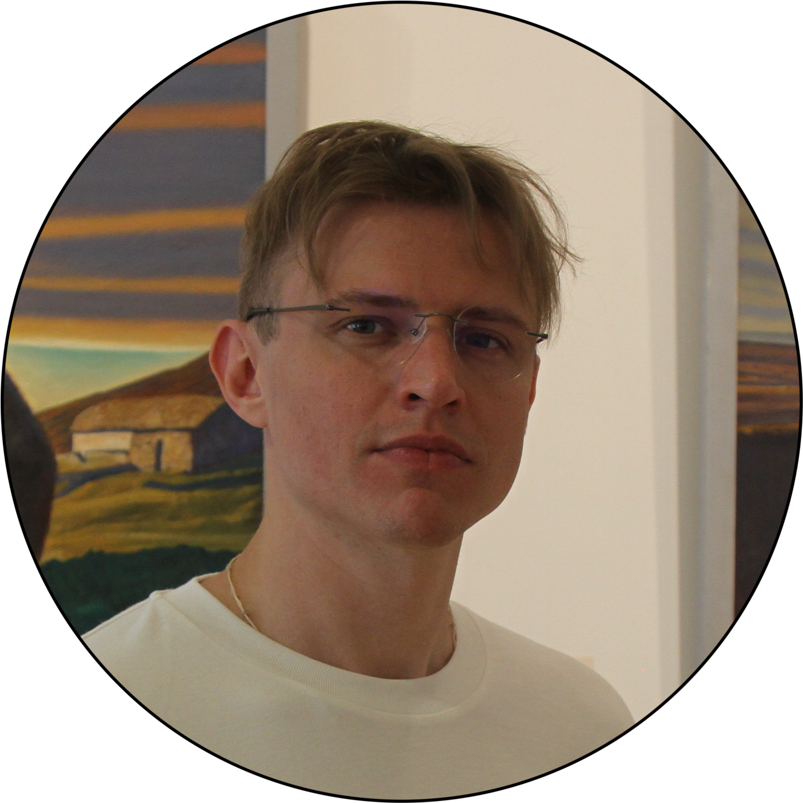 |  | Maksim Omel’chenko  Mobile Developer  Kotlin | Java | KMP/KMM | Android | iOS
Summary  Android expert delving into Swift and Kotlin Multiplatform.  Focused on efficient, user-centric mobile app development.  Contact  +79896334901 (WhatsApp)  telegram: @ric_i_am  Mailboxes:  maksim_omelchenko@zohomail.eu  Portfolio:  https://github.com/OmelchenkoMaksim  TOP SKILLS  Object-Oriented Programming (OOP)  Android Kotlin Java  LANGUAGES  English (Professional Working)  Russian (Native or Bilingual)  Certifications  EF SET Certificate (English)  https://cert.efset.org/U86dt2  Certificate for socially useful activities in the field of IT education |  | Education  Rostov State University of Civil Engineering  Master's degree, Engineering (June 2008 - July 2013)  Experience  MTS Bank - Android Developer  March 2023 — Present  Moscow | remote | full-time  https://www.mtsbank.ru  As an Android Developer at MTS Bank, I've been involved in enhancing the development and maintenance of our mobile applications with a focus on practicality and efficiency. My contributions include:  - Feature Development: Architected and implemented a plugin for generating new features, streamlining the development process for product teams. This tool enables rapid, consistent MVI-based feature integration within our Dagger architecture, substantially reducing time spent on code reviews and feature deployments.  - Code Optimization: Updated our dependency injection framework from a service locator model to Dagger, improving the application's stability and reducing build times, decreasing from 15 to 12 minutes.  - Collaborative Support: Assisted in the integration and adaptation of Android developers from different teams, ensuring they could effectively contribute to our projects.  - Recruitment Support: Participated in the hiring process to select and bring in skilled Android developers, contributing to our team's growth and expertise.  Yandex Practicum - Kotlin & Android Tutor  November 2022 — December 2023 (1 year 2 months)  Moscow | remote | part-time  https://practicum.yandex.ru  In my role at Yandex as a Kotlin and Android tutor, I contributed to the education of aspiring developers by simplifying and conveying complex programming concepts. My responsibilities included:  - Curriculum Development: Assisted in the creation and delivery of detailed online lessons and webinars, focusing on key aspects of Kotlin and Android development.  - Supportive Tutoring: Provided support and guidance through interactive lesson plans, aiming to clarify challenging topics and foster understanding.  - Assessment and Feedback: Offered constructive feedback based on student performance, helping them progress and overcome learning hurdles.  - On-demand Assistance: Was available for real-time inquiries, aiming to demystify topics related to software architecture and design patterns.  Andersen Lab - Android Developer  August 2020 - March 2023 (2 years 8 months)  Minsk | remote | full-time  https://people.andersenlab.com  In my capacity at Andersen Lab, I was involved in the development of mobile applications for prominent banks such as Sberbank and VTB.  My responsibilities included:  - Architectural Patterns Application: Utilized patterns like MVVM, MVP, and MVI to ensure app reliability and maintainability.  - Database Technology Utilization: Worked with Room, Firebase, and Realm to optimize data handling.  - Reactive Programming Integration: Employed LiveData, Flow, and RxJava for reactive app features.  - Concurrency Management: Applied Kotlin Coroutines and WorkManager for efficient task management.  - Data and View Binding Implementation: Used binding techniques for improved app UI and data interactions.  - Dependency Injection Enhancement: Implemented Hilt and Dagger 2 for better dependency management.  a1qa - QA Automation Engineer (Java)  January 2018 - July 2020 (2 years 7 months)  Minsk | remote | part-time  https://www.a1qa.com  In my role as a QA Automation Engineer at a1qa, I focused on upholding software quality through methodical testing and collaboration.  My contributions included:  - Functional and UI Testing: Performed thorough testing to ensure user interfaces were intuitive and functional, enhancing user satisfaction.  - Test Case Development: Created detailed test cases using Selenium WebDriver to meet precise business specifications.  - Defect Tracking: Utilized Jira to diligently track and report issues, facilitating swift and effective resolutions.  - Team Collaboration: Engaged in regular stand-up and planning meetings, contributing to the alignment of project objectives and timelines.  - Cross-functional Cooperation: Worked alongside Product Managers and developers, providing essential QA insights and fostering a cohesive team environment.  POLYUS - System Administrator  March 2017 - July 2020 (3 years 5 months)  Krasnoyarsk | onsite | full-time  https://polyus.com  In my tenure as a System Administrator at POLYUS, I dedicated my efforts to ensuring the steadfast performance and security of our systems.  My role encompassed:  - Troubleshooting and Coordination: Addressed system issues through effective troubleshooting and collaborated with external parties for swift resolutions.  - System Improvement: Took initiative in identifying and implementing enhancements to bolster system reliability and performance.  - Security Oversight: Administered security protocols to protect against unauthorized access and threats, maintaining system integrity.  - Proactive Monitoring: Consistently monitored and assessed the system's security stance to preemptively identify and rectify potential vulnerabilities.  - Technical Support: Provided in-depth support and analysis for system-related inquiries, ensuring thorough understanding and issue resolution.  - Documentation Management: Kept meticulous records of system configurations, updates, and operational procedures, aiding in clarity and consistency.  SKIlls  Programming Languages:  - Kotlin (5 years of experience)  - Java (6 years of experience)  Platforms:  - Android development experience spanning 4 years  - Learning iOS development just for fun  - Engaged in learning and applying Kotlin Multiplatform for 2 years  - Proficient in using Gradle for build automation and DSL  Platform Technologies:  - Applied MVVM and MVI architectures in various projects  - Utilized databases such as Room, Firebase, and Realm  - Experienced in Reactive Programming with LiveData, Flow, and RxJava  - Skilled in managing concurrency in Kotlin with Coroutines and WorkManager  - Gained 2 years of experience in Jetpack Compose for modern UI development  - In-depth experience with XML, Data Binding, and View Binding for efficient UI coding and management  - Skilled in leveraging various Jetpack Libraries to enhance app robustness and maintainability  - Proficient with dependency injection using Dagger for 5 years and Koin for 2 years  Environment Technologies:  - Utilized Bitbucket, GitLab, and Jira for 3, 4, and 5 years respectively  - Experienced in code quality and CI/CD processes with SonarQube (3 years), Fastlane (2 years), and Jenkins (3 years)  Testing:  Conducted Unit and Integration Testing using JUnit, Mockito, and Mockk  Tools:  Regular use of Postman and Charles for API testing and debugging

